***\*\* To Submit all this Exercise Create a Single word file and copy all your scripts along with screenshot of the OutPut. And Share it on*** [***nehalole1115@gmail.com***](mailto:nehalole1115@gmail.com)

1)Create a query to link together the following 3 tables:

* **tblContinent**
* **tblCountry**
* **tblEvent**

Your query should list out those events which took place in either:

* the continent called **Antarctic**; or
* the country called **Russia**.

Here's what your query should show:

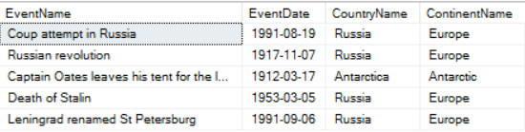

*Events in a cold climate ...*

Save this query as **Brrr**, then close it down.

2)Create a query which uses an inner join to link the categories table to the events table (they share a column/field called **CategoryId**):

Change the inner join to an outer join, so that you show for each category its events - even when there aren't any:

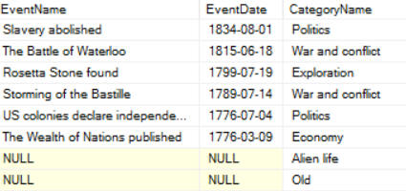

*You have a couple of extra rows, making 461 in total.*

Show only those categories which don't have any corresponding events:

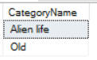

*It seems unlikely they'll be any events for the first category, but you never know ...*

Save this query as **Empty categories**, then close it down.

3)Create a query using an outer join to list out those countries which have no corresponding events.

*If you succeed, you should get a country which has no events despite having the world's fourth largest population.*

Save this query as **Indonesia**, then close it down.